***Using Logs to Help You Track Down an Issue in Windows***

***Jenitha Reddy Kurra***

***18Z327***

**Viewing Logs on Windows:**

* Here, application logs are to be examined. To view application logs, click on Windows Logs and select Application
* Locate the logs to be fixed. Click on a log entry to view more details.

**1.Low Disk Space:**

This log warns about a large file that is taking up disk space, but it does not specify the file name.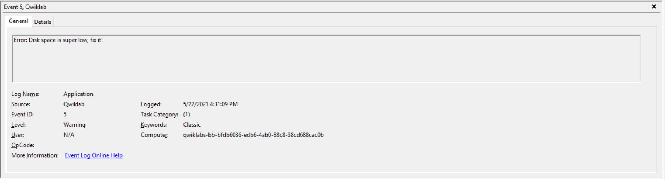

Open file explorer and configure the search such that the size of the file is **‘gigantic’** (this locates files whose size exceeds 128 MB). Delete the ‘ultra_merge_large’ file.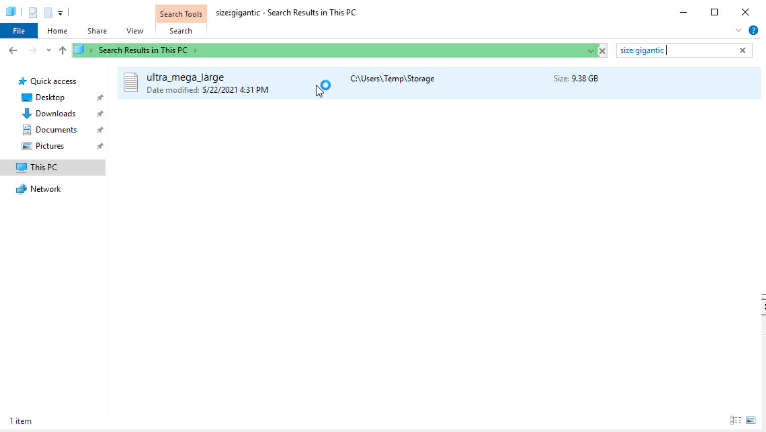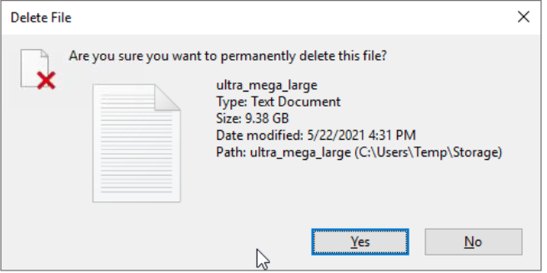

**2.Corrupted File:**

This log warns to remove acorrupted file in the C:\ directory.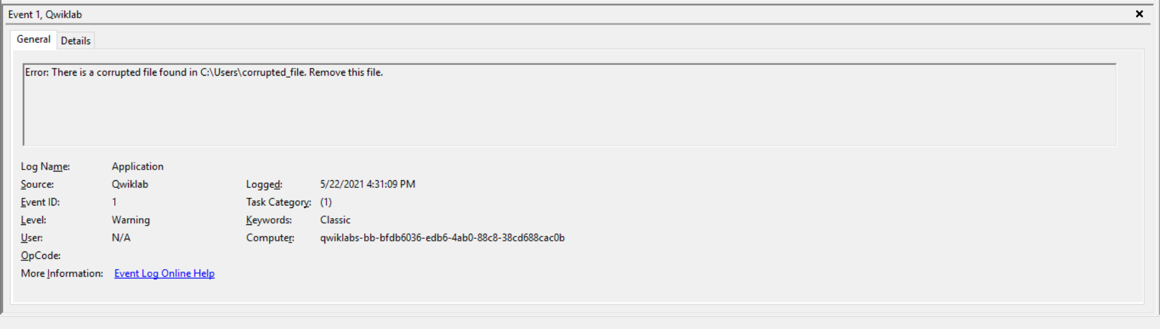

Search the file explorer for the path specified in the log (C:\Users\corrupted_file). Delete the ‘corrupted_file’.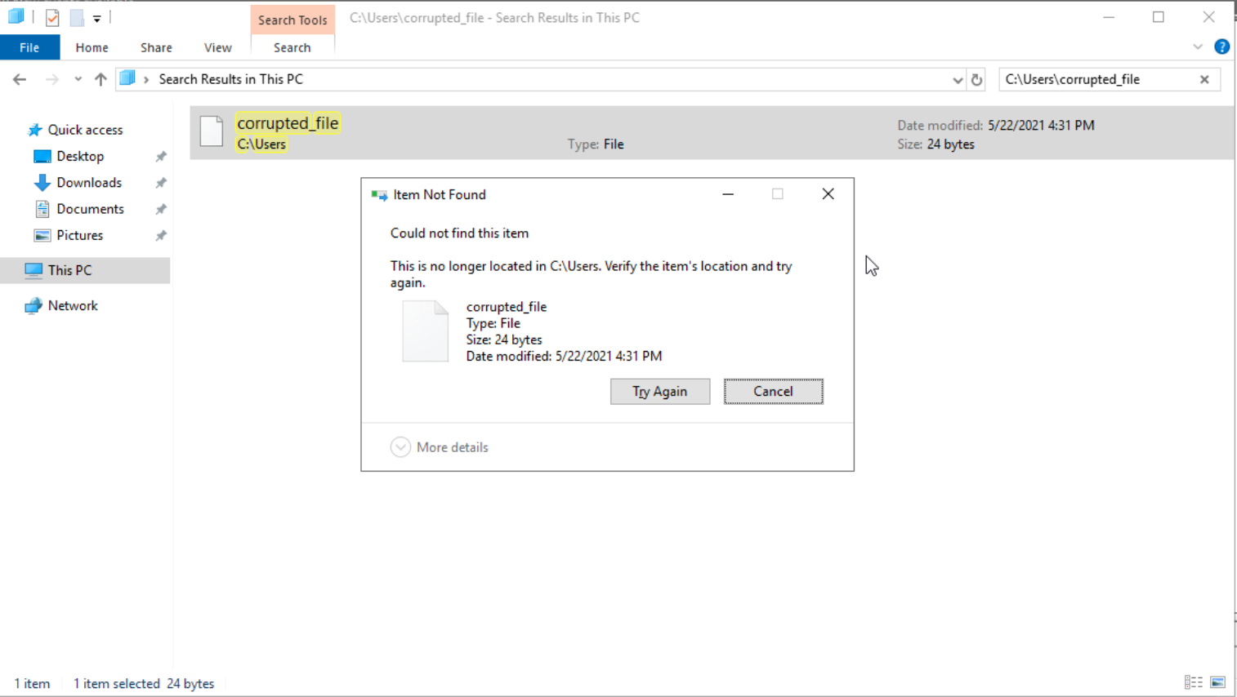

**3.Update VLC:**

This log warns about a software package that is out of date and asks to upgrade to the latest version.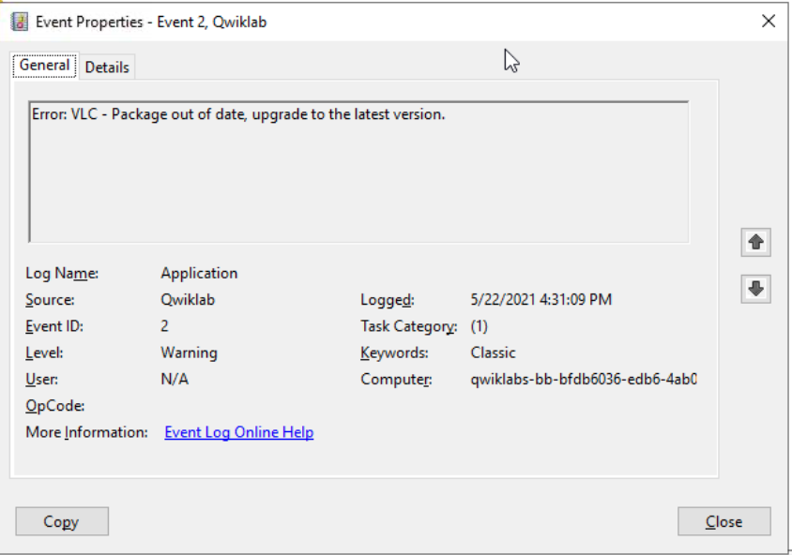

Navigate to the directory where the VLC package is located

(C:\Users\qwiklabs\Downloads).

Now the package can be upgraded by executing the following commands:

$VLC_URL = "https://download.videolan.org/vlc/last/win64/";

$DOWNLOAD_DIR = "C:\users\qwiklabs\Downloads\";

$GET_HTML = Invoke-WebRequest $VLC_URL;

$FILE=$GET_HTML.Links|Select-Object @{Label='href';Expression={@{$true=$_.href}[$_.href.EndsWith('win64.exe')]}} | Select-Object -ExpandPropertyhref;

$URL = ($VLC_URL+$FILE);

$OUTPUT_FILE = ($DOWNLOAD_DIR+$FILE);

(new-object System.Net.WebClient).DownloadFile($URL, $OUTPUT_FILE);

cmd.exe /c "$OUTPUT_FILE /S"

**4.End Malicious Process:**

This log warns about a malicious process and asks to terminate it.

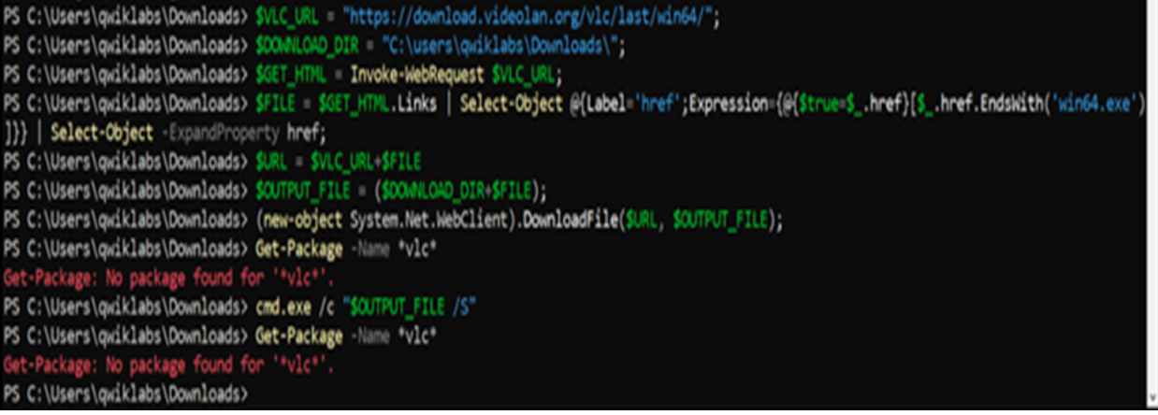

Search for the process by its name (totally not malicious) using **Get-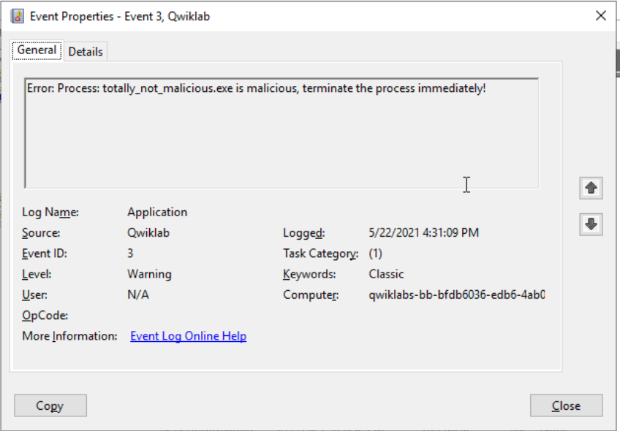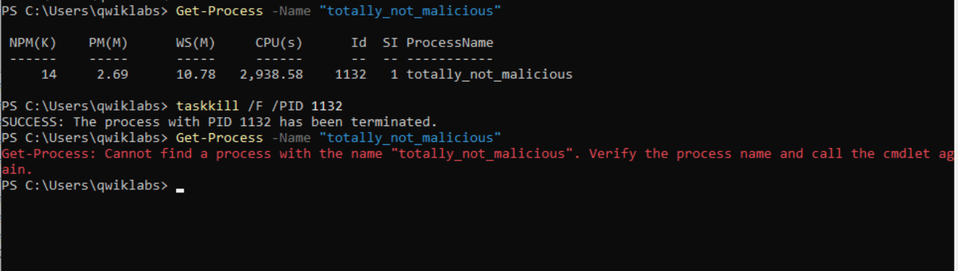Process -Name [process_name].**This gives the process ID. Terminate the process using **taskkill /F /PID [process_id].** Verify termination using **Get-Process -Name [process_name].**

**5.Fix Permissions:**

This log warns that write permission is denied for everyone for the file specified in the path.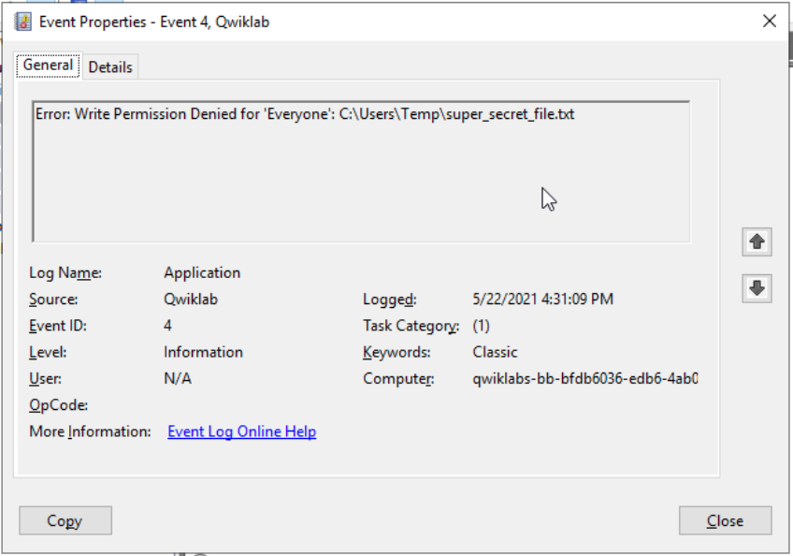

View the existing permissions for the specified file. Grant write permission for Everyone.